June 2012 Service Anniversary Honorees (25+ years)

Please note – the following honorees have declined the invitation to speak:

- Anne Berman
- Lisa Boccanera-Stinsman
- Barbara Cooney
- Geames Little
- Rita O’ Beirne
- Angela Salverian
- Joan Steptoe
- Dayna Washington

This is also noted at the bottom of each honoree’s page.

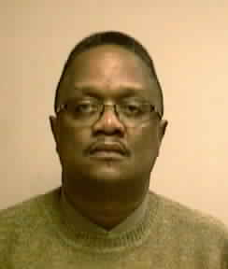 | Jackie Barber (jăkē barbŭr)  Supervisor, Community Outreach  Government Markets Operations  25 years

- Before he joined the company, Jackie worked at Pennsylvania Blue Shield, which happened to be located in the same building as IBC.
- Jackie applied for a job here after hearing great things about the company from people he knew. What he remembers most about that time was the close-knit, family atmosphere.
- In his current role, Jackie raises awareness in the community about the Caring Foundation. For him, it’s extremely rewarding to help families get health coverage for their kids.
- In his spare time, Jackie enjoys exercising and spending time with his family. He’s a fan of smooth jazz and uses his affinity for music to arrange the compilations that are played during the Caring Foundation book fairs.

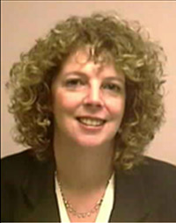 | Anne Berman (ăn bŭrmăn)  Manager, Requirements Management  Informatics  25 years

- Anne worked at IBC as a contractor for one year before being hired full-time. What attracted Anne to the company was our reputation as one of the top places to work in Philadelphia.

- Working in an area where there is constant change, Anne believes her flexibility and dedication allow her to adapt well in many situations.
- Anne appreciates the many career development and educational opportunities that IBC offers. She has taken several courses that helped enhance her managerial skills, and considers IBC University to be a valuable resource for all associates.
- When she’s not working, Anne spends as much time as possible with her family. Whenever they get the chance, they enjoy traveling to new vacation spots.
*Associate has declined invitation to speak.

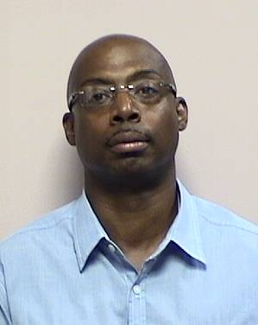 | Geames “Gene” Little (gēmz “jēn” lĭtŭl)  System Specialist  Information Services – Business Office  25 years

- Gene joined our organization as a Payroll Analyst. He was eager to join the company because he heard IBC believed in promoting from within.
- While his degree and experience are in Accounting, Gene was able to move from the Finance department to Information Services. Looking back, he is grateful that IBC provided this opportunity, and it’s why he’s proud to tell people he works for our organization.

- Gene says his positive attitude and success-oriented approach toward projects are the cornerstones of his success at IBC.
- When he’s away from the office, Gene enjoys playing golf, basketball, softball, and traveling with his family. Speaking of family, Gene’s aunt, Jean Vorters (jēn vōrtŭrz), also works at IBC and is here to celebrate his special milestone.

*Associate has declined invitation to speak.

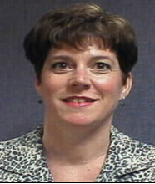 | Margaret “Margie” Giannetti (mărgărĭt “mărjē” jēănětē)  Manager, IS Business Relationships  AmeriHealth Administrators  25 years

- Margie came to IBC on her very first assignment when she worked for a consulting firm. She must have done a good job because after nine months, she was offered a full-time position with our company.
- Margie was the first IBC associate to transfer to AmeriHealth Administrators when that organization became part of the Family of Companies.
- She was also a part of the Building Change Leaders program – an experience she says gave her important skills she was able to use during several transitions that have taken place at AmeriHealth.
- Working for our company has definitely been life-changing for Margie. She met her husband Gary while working at IBC.
- When she’s not at work, Margie likes to watch her son play for Ursinus (ŭrsīnūs) College’s football team. She also likes to bike and watch TV with her daughter.

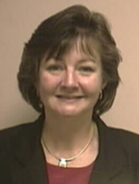 | Ann Petroziello (ăn pětrōzělō)  Senior Case Manager  Clinical Services  25 years

- Ann worked as a nurse in intensive care for a local hospital before she joined IBC. She enjoyed the traditional hospital setting, but wanted to explore the insurance side of health care.
- She was hired as a Second Surgical Opinion Nurse. At that time IBC only had about 20 nurses. Today, she is proud that we have more than 200 nurses on staff!
- After 25 years, Ann knows that coming to IBC was the right decision. She gets great satisfaction from helping our members and their families.
- Ann isn’t the only one in her family that works at IBC. Her cousin Theresa McGrath (těrēsă mcgrăth) also works in Clinical Services and is here to celebrate Ann’s milestone.
- Away from work, Ann likes to read, ski, and go to the theatre. She’s also looking forward to vacationing with her family in California this summer.

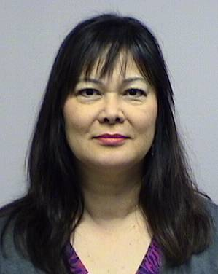 | Angela Salverian (ănjělă sălvārēŭn)  Senior Product Manager  Marketing Services  25 years

- Angela joined our organization as an Accounting Manager with Inter-County Health Plan. She recalls that it was a dynamic time since the company was among the earliest insurers to offer PPO plans in Pennsylvania.
- Several years later, Angela was part of another exciting time in the company’s history when she helped create the Marketing Services department at AmeriHealth Administrators when she was with that organization. Today, she is proud that this business area has grown so tremendously.
- Angela appreciates the impact our company has in the community, and it makes her proud to tell people she works for IBC.
- Outside of work, Angela enjoys traveling with her family. They love the beach, so it’s often to coastal and island spots for them.

*Associate has declined invitation to speak.

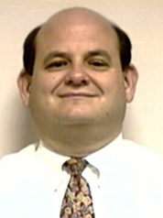 | David “Dave” Snyder (dāvĭd snīdŭr)  Chief Information Security Leader  Information Security Office  25 years

- Before joining Vista Health Plan, which eventually became part of IBC, Dave had an interesting job developing and testing guidance systems for nuclear missile systems.
- Dave says his greatest strengths are being flexible and understanding the needs of his customers so the right solution can be implemented.
- Dave credits IBC for expanding his education. Through the tuition reimbursement program, Dave earned his Bachelor of Science from St Joseph’s University. He’s also achieved several Information Security certifications.
- When he’s not at work, Dave spends quality time with his family, traveling, camping, and going to the beach. Dave also enjoys water activities and is a certified scuba instructor.

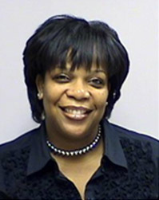 | Joan Steptoe (jōn stěptō)  Senior Business Systems Analyst  Finance  25 years

- Joan came to IBC as a cashier in Walk-In Services after hearing great things about the company from family and friends who worked here at the time.
- She enjoys working with numbers and problem solving, which is why she has spent most of her IBC career in Finance.
- Joan believes the secret to her success has been her flexibility, reliability, and commitment.
- Joan’s passion for community involvement makes her a perfect fit for our company. In the fall, she plans to volunteer to read to elementary school students through the Philadelphia Reads program at IBC.
- Outside of work, Joan enjoys spending time with her family, reading, and traveling. She hopes to visit Hawaii on her next vacation.

*Associate has declined invitation to speak.

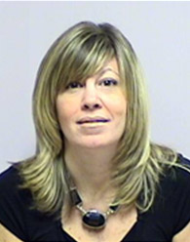 | Lisa Boccanera Stinsman (lēsă bōcănāră-stĭnsmăn)  Associate Account Executive  Sales  25 years

- Lisa graduated from Moore College of Art & Design when she joined IBC. Her first job was in Marketing, which was a good fit since it was her minor in school.
- What Lisa loves most about her current job is the opportunity to work with a diverse clientele. For instance, she once had to walk through the general population at a local prison to help coordinate an Open Enrollment Fair for the prison staff.
- Those who work with Lisa know her as extremely helpful and knowledgeable, but she’s also known for her great sense of fashion. In fact, they refer to her as the “Carrie Bradshaw” of IBC.
- For Lisa, IBC has become a family affair. Her cousin Loretta DeFeo (dēfāo) also works for the company, and is here today to help us celebrate.
- Lisa is still an artist at heart. Outside of work, Lisa enjoys drawing and decorating.

*Associate has declined invitation to speak.
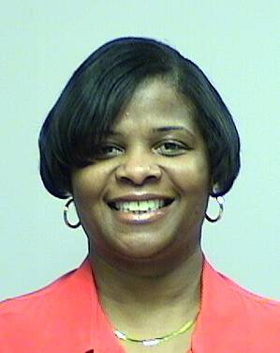 | Dayna Washington (dānă wăshĭngtŭn)  Sr. Claims Payment Adjuster  Processing Services  25 years

- Dayna joined IBC because she wanted to work for one of the most prestigious companies in the region.
- From her first day, she felt as though working at IBC was like being part of a family.
- Dayna says that she loves her job because it’s never boring and each day presents new challenges.
- She believes that she works well with her coworkers because she is always a team player, easy to work with, and always willing to lend a hand to anyone who needs her help.
- To relax, Dayna likes to watch movies, go horseback riding, and spend time with her grandchildren and her friends.
*Associate has declined invitation to speak.

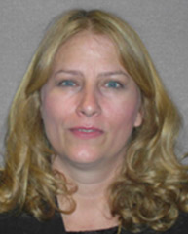 | Barbara Cooney (bărbră kū-nē)  Office Manager  Legal  30 years

- Barbara joined the IBC Family of Companies as a Legal Secretary. She says she has benefited from working with several talented and supportive managers over the years.
- One of Barbara’s proudest accomplishments while working at IBC was when she earned her Bachelor’s degree in Business Administration from Temple University. She was the first on her father’s side of her family to graduate college.
- Barbara is known for being well organized and prepared. In addition to her current role, she is the IBC Board Administrator and has worked closely with every CEO during the last 30 years.
- Away from the office, Barbara likes to be with her family. They enjoy traveling and planning trips together. During her own quiet time, she likes to sit on the beach with a good book.
*Associate has declined invitation to speak.
(Present BCBSA plaque to Barbara)
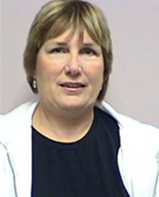 | Eileen Sinni (īlēn sĭnī)  Network Services Analyst  Contracting/Provider Networks  35 years

- Eileen joined the company one week after graduating high school and has been here ever since! Once she realized the many opportunities at IBC, she knew this was the right company for her.
- Over the years, she learned many facets of our business through the various positions she has held within the company, including claims, member services, and provider services.
- What Eileen loves most about IBC is that we’re there for people during the most vulnerable times in their lives.
- Family is important to Eileen so she spends most of her free time with them, especially her three granddaughters. One of their favorite things to do as a family is go to North Wildwood during the summer.

(Present BCBSA plaque to Eileen)

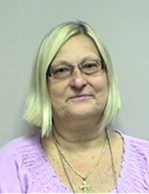 | Rita O’Beirne (rētă ō-bŭrn)  Lead Business Systems Analyst  Contracting/Provider Networks  40 years

- Rita was working at a jewelry store when her coworker and friend found a job at IBC. Rita decided to follow her, and she has been here ever since.
- Over the years, Rita has earned roles of increasing responsibility. She is currently part of a team that will help our company transition to our new core platform.
- While she has taken several developmental courses at IBC, Rita says she has gained the greatest amount of knowledge simply by doing her job.
- Rita’s secret to her success has been accepting change and maintaining a strong professional network with as many associates as possible.
- Outside the office, Rita enjoys spending time with her family. She and her husband run a monthly prayer group at their home.
*Associate has declined invitation to speak.
(Present BCBSA plaque to Rita)

